4.5 Merge and join data

Dataflow Gen2
In a Dataflow Gen2, in the ribbon, click on Merge Queries (or Merge Queries as New, if you want to generate a completely new merged query):
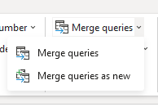
You will be asked to specify on which keys you wish to merge your two queries, as well as specifying a join type:
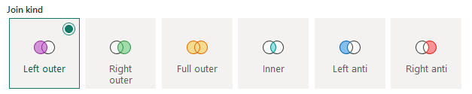

T-SQL Data Warehouse
- In a T-SQL query, you can define a join between two (or more) tables, like this:
SELECT pv.ProductID, v.BusinessEntityID, v.Name
FROM Purchasing.ProductVendor AS pv
INNER JOIN Purchasing.Vendor AS v
ON (pv.BusinessEntityID = v.BusinessEntityID)
WHERE StandardPrice > $10
AND Name LIKE N'F%';

